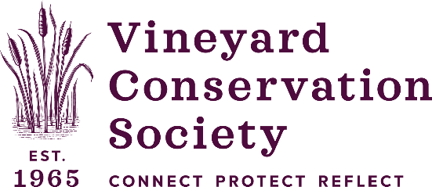
P.O. Box 2189, Vineyard Haven, MA 02568
Phone (508) 693-9588
www.vineyardconservation.org
info@vineyardconservation.org

April 15, 2024
Paid Intern position available

Passionate about the environment? Come work with us this summer!
VCS is looking for an energetic individual who’s passionate about protecting the environment. Summer is always a bit hectic, and our team is looking for a little extra support to help our events and programs run smoothly. Some of the work is basic office support and help with event logistics, but we would also love to involve you in our initiatives and campaigns as the season progresses. If you are enthusiastic about environmental work and are eager to learn more about VCS while supporting our programs, please send us a letter of interest and resume. Depending on your interests and skill sets different opportunities may be available. Please include the dates and times you are available. We are looking forward to meeting you!
· 10-15hrs/week, paid $18/hr.
· Light office duties & errands: mailings, donor database research & support, filing & copying
· Assist with Events: set up & cleanup, donor interaction–phone, email, in person day of, help with coordination of vendors and supplies.
· Assist with programming: Vineyard Lawns campaign, Beach BeFrienders monthly beach clean-up, Plastics & Waste reduction, and more
· Help with social media (Instagram mostly)
· Design skills a bonus (InDesign, Canva)
· Start ASAP
If interested, please send your resume to info@vineyardconservation.org

